Board Meeting Minutes
March 2, 2018
8:30am - 10:00am
Conference Call

- Tim Slocum(present)  - Mary Germann (not present)  - Callie Andrews (present)  - Bryant Cornett (present)  - Jay Dennard (not present)  - Karen Manno (present)  - John Henson, MD (present)  - Craig Honaman (present)  - Matt Jernigan (not present) | - Karen Manno (present)  - Tripp Penn (not present)  - Ty Bozkurt (present)  - Marlene Sidon(present)  - Larry Tyler (present)  - Bobby Ryan (present)  - Lynn Scroggins (present)  - Doug Gregory (present)  - Sepi Browning (present)

Agenda Items | Time | Responsible Party
Welcome & Roll Call | 8:30am | Tim Slocum
Approval of Minutes first approval Larry , second Ty, all approved | 8:33am | Marlene Sidon
Treasurer’s Report  It has been determined that a Sun trust account is not able to provide us what we need. First Citizens or Affinity is better able to meet our needs. Bryant has experience with them and knows what they will deliver. Some of the protocols with the bookkeeper would be better supported with First Citizens. Both would allow a tiered access to restrict access to the checkbook. Bryant is requesting approval to go with one of these two. John suggests we take the committee recommendation and Doug seconds. Tim asked Bryant to abstain due to disclosures. John offered 1st motion, Marlene 2nd. Approved. No opposition.  Sun trust did provide a credit card and we should anticipate the delivery. Once it arrives, discard the debit cards. Discussed total balances in multiple accounts. New email address, gahebilling@gmail.com is the email address for invoices or payment requests.  The Finance Committee is still being formed. We are seeking one more finance professional. Tim and Bryant will discuss recommendations off line.  We are seeking to conduct an audit, which will not be a full audit, rather a financial statement of our systems to ensure adequate controls. The cost will be $2,500- $3,500 conducted by BMM&P, our current accounting firm. They will also review our insurance policy. The audit will be complete by mid to late summer. We have approved for the bookkeeping services for $1000.00 per year. We have already paid $500 for tax filing. We are seeking approval for the financial audit review only. We can determine how often we would repeat this audit review. Possible every three years.  Motion to engage BMM&P 1st motion to approve John Henson MD, Bobby 2nd motion to approve. All in favor | 8:35am | Bryant Cornett
Regent’s Report  Larry is completing his term. His last Regent newsletter will go out on Monday. Larry has been asked to be a Senior Advisor to the Board. | 8:40am | Larry Tyler
Administrator’s Report  No outstanding issues, programs are proceeding and working on the communications with various events. With the change in the ACHE deadlines for our event filing, there is a need to change the workflow. Will defer to committees for other report outs. | 8:45am | Karen Manno
Presidents Update / Announcements  - 2018 Officers voted at the November 16, 2017 annual meeting. Identify the below officers for 2018. 1st Motion Ty 2nd motion John. All approved.  - 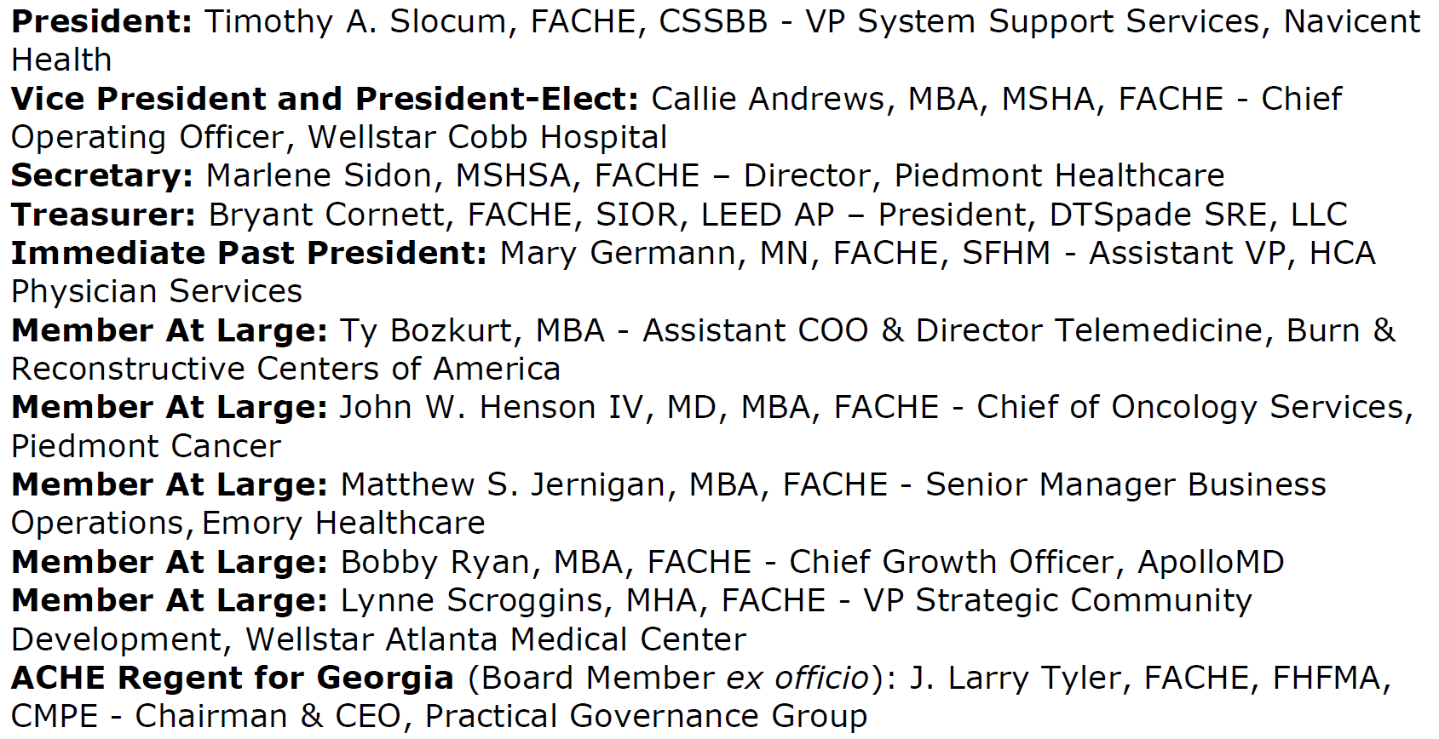  - Update from ACHE- change in educational hours will evolve. Request that Doug and Sepi work with Karen to confirm our process flow. Tim has checked with Tierra and we do not yet have our new goals yet for this year.  - 2018 ACHE Congress: March 26-29—anyone planning to go, please let Tim know so that dinner can be planned. Email if you are attending and if you are bringing a guest. Please email Tim and John Henson.  - Organizational Chart Review & Discussion-Reviewed Board structure and desired to clarify Board seats and committee chairs and ensure that the bylaws support the structure. Recommendation for the group is as follows: The number of member at large position remain at five. Reason is that bylaws allow the Board to appoint other Board members with voting privileges. We aim to address a plan to approve Sepi and Doug as Board Members with voting privileges. Full Board, 5 members at Large and the officers would need to vote to add Board Members. John commented that this is a good idea. Members at Large need to be leading committees. John asked if the Board could have the ability to approve vs. going through the fall nominating process. Tim explained that the new Board in January would appoint the new members. Members at Large should represent the diversity and geography across GA. Tim recommends that our Bylaws be amended to represent this ACHE language. Questions about the ability to measure this. Tim suggests our bylaws statement regarding diversity and geography needs to be more overt than it is. Suggest it could be included in a mission or goal statement. Tim believes we need to include in the bylaws.  - There are a number of chapters that are having two- year terms. We are exploring this. Ty and Bryant will join a team to explore this option. Craig suggest we do not need a bylaw change, since officers are already committed for a 3-year process, perhaps that assignments are different. However, Tim clarified that this would include all roles. This warrants a discussion. Member at Large Board Member /Vice Chair who is not a Board Member. Marlene and Lynn will join Ty and Bryant the group and Lynn. Marlene will lead.  Approval requested to add as voting Board Members;  Sepi Brown  Doug Gregory  Sonya McClendon  Propose a motion to appoint these individuals as voting Board Members for 2018. 1st motion Ty, 2nd John, all in favor. | 8:50am | Tim Slocum
Committee and Sub-Committee Reports:
Programs Committee, incl. Regional and Joint Programs  All on track, January program moved to October. Need to discuss what we want to do regionally with our expanded ability to teleconference. Do we continue to conduct meetings in various regions or focus on teleconference? Tim mentions that the LPC model has had good success. Suggests that Doug and Lynn review and make a recommendation on the best structure for GA. Larry explained that the focus of the teleconference would be to broadcast regionally and the LPC would broadcast the event and ensure that there is good networking after the broadcast. Karen suggests that Sonja has experience with LPCs in GAHE. Tim also for Macon. LPC to host. Sepi offered to help with this planning.  Tim said that the Feb event was good. Session was full and a challenge to fit walk in attendees.  April is value- based reimbursement. Still exploring May, it may be cybersecurity. | 9:05am | Doug Gregory / Lynne Scroggins
Senior Executive Committee  Tim gave this report, Senior, exec on Deck April 19 at SunTrust park Tom Price invited. Gene Woods at Navicent to co present merger, acquisitions and partnerships in the fall. Bryant suggested that we use Spaces at the Battery | 9:15am | Mary Germann
Growth & Satisfaction Committee  More on campus education March 21 program at East Ga Med Center. Both student and non-student members can attend. Three speakers are engaged. Program development and leadership. Putting the budget together for review light box lunch. Goal 25 attendees. This is a good learning opportunity to determine the best way to engage the schools. | 9:20am | Ty Bozkurt
Fellow Advancement Committee  Tim reported for Matt. July BOG, Sept Macon, and So Carolina to promote their program. We may offer a dues promotion for 2018, however it would be later in the year. No consideration for now. We do not yet have our goal for fellow advancement for this year. Larry mentioned a project for a program, which is moving along. Doug asked when materials would be posted online. Ty said we need to download the video. Those who paid should have complimentary access. Need a code to access. Others do we want to charge a fee, and if so how would we administer the fee? Ty asked how we move forward with the content. Sepi said she would work on this. | 9:25am | Matt Jernigan
Career Development Committee | 9:30am | Sonja McLendon
Sponsorship Committee  We have been working with programs and communications to ensure we are communicating the benefit value of the sponsorship, and working with Doug to ensure that as programs come on where we can get a single sponsor. HCA and Stenega are the only sponsors who are outstanding for payment. Analyzing the exposure of member to sponsors and relaying that back to the sponsors is another key initiative. | 9:40am | Bobby Ryan
Physician Executive Committee  Larry wanted to comment that Christine and Larry viewed the GAHE website and see a need for a landing page for Physician Execs. John said we indeed have good content on our website with photos, etc., will send the link, under the career focus. Larry did review.  Dr. Henson reported he attended a Cancer meeting two days ago and spoke with The American college of Physicians, to promote ACHE and engage us. GA Chapter, Leader will address the benefit of ACHE with the chapter. Recent call was participate by 16 doctors ,a question was posed, at what point do we include other leaders who are not physicians? Congress, hosting two receptions and Lily is speaking. Larry suggests that cross-pollination with other leaders is best at the C suite level. | 9:45am | Dr. John Henson
Communications Committee  Accomplishments in the last few months. Event worksheet for programs committee. Messaging calendar, ownership of all events per month by a communication committee member. Request newsletter every 2 months with a regular checklist of content. Tim will have the President letter published next. Submission deadline March 15. Published March 31. The goal is to have a section each time to represent a different committee.  Action items, many operational items, focus on marketing our sponsors. Special events, social media campaign.  By March 20, google analytics initiated. Webmaster initiation activities on the way. Email blast template and newsletter template freshen up underway. Stats reviewed each month. Following social media stats. Website hits. Aug-Feb. In Feb 746 visitors. Will keep up with the stats.  Discussion about posting minutes and Board materials on our web site. Should this be protected access or open to all members. Larry suggests that the Board may view general session view by all, private sessions could be protected. | 9:50am | Sepi Browning
Outstanding / Other Business  - Investigation of a Foundation / Fund  Call this afternoon with SE Texas to learn about their foundation. | 9:55am | Group  Dr. John Henson
Topics for Next Meeting(s) next month is in Macon | 10:00am | Group
Conclusion & Adjournment | 10:05am | Tim Slocum

Next Board Meetings:
- Friday, April 6th, 2018 at Navicent Health in Macon
- Friday, May 4th, 2018 via Conference Call

